KENDRIYA VIDYALAYA AGAR MALWA
WINTER BREAK HOLIDAY HOMEWORK

Date: 25 Dec. 2023 to 3 Jan. 2024
CLASS -7TH

MATHEMATICSf

Q.1 Write the five rational numbers between -4/5 and -2/3
Q.2 Draw the number line and represent the following rational numbers.
a) 4/5 b) -7/8 c) -5/6 d) 3/5
Q.3 Find which of the following is greater.
a) -3/4 or -2/3 B) -4/7 or -6/8
Q.4 solve the following
a)5/4 + (-11/4)
b)8/7 ÷ 4/12
Q.5 Find the area of the following

Q.6 Triangle ABC is an isosceles triangle with AB= AC=7.5cm and BC= 9cm. The height AD from A to BC is 6 cm.Find the area of triangle ABC.What will be the height from C to AB, i.e.,CE.
Q.7 A Flower bed is surrounded by a path 4m wide. The diameter of flower bed is 66 m. What is the area of this path. (π=3.14)
Q.8 How many times a wheel of radius 28cm must rotate to go 352m.(π=22/7)
Q.9 If p= -10 find the value of p²-2p-100.
Q.10 Simplify the following expression
2a²b + 2ab +2bc +ab + bc + a²b

हिन्दी (Hindi)
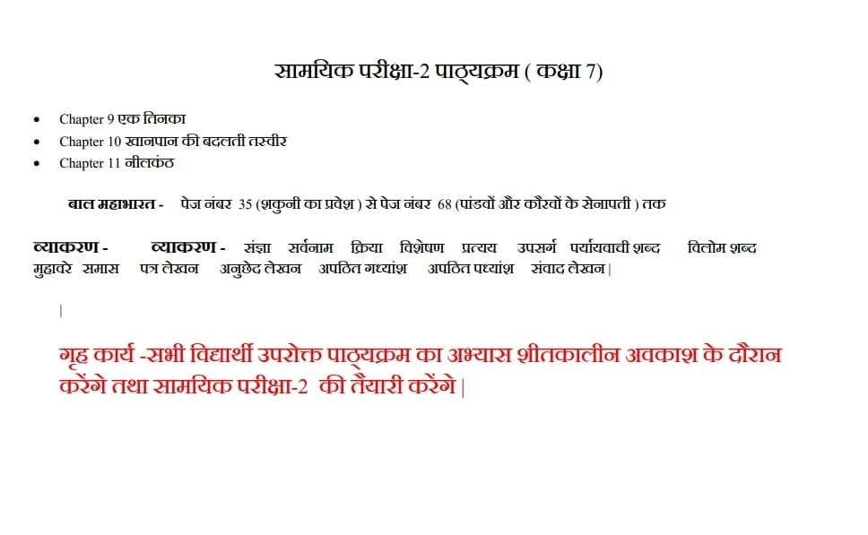

ENGLISH
READ & LEARN Questions & answers
Honey Comb
Chapter -QUALITY,
EXPERT DETECTIVE
POEMS:-
TREES,
MYSTERY OF TALKING FAN
SUPPLEMENTARY BOOK:-
THE BEAR STORY,
A TIGER IN THE HOUSE
Write an application to the principal for 5 days leave on the occasion of your sister's/ uncle's marriage.
Write a Bio-Sketch on any great personality.

SCIENCE
- Write the differences between :
- (I) Aerobic and anaerobic respiration.
- (II) CROSS POLLINATION AND SELF POLLINATION
- (III) Xylem and phloem
- (IV) UNIFORM AND NON UNIFORM MOTION.
- (V) Sexual and asexual reproduction
- 2. Draw the labeled diagram of the following:
- (i) Human respiratory system.
- (ii) Human excretory system
- (iii) Soil profile
- (iv) Flower , stamen and pistil
- (v) Human respiratory system
- (vi) Human heart
- 3. Define the following terms
- (i) Excretion (ii) Respiration (iii) Fertilization (iv) Pollination
(v) Double circulation of blood
4. Why is excretion necessary?
5. What is transpiration ? why is it a necessary evil?
6. Describe the various ways by which the seeds are dispersed.
7. The odometer of a car reads 57321 km when the clock shows the time 8:30 am. What is the distance moved by the car if at 8:50 am , the odometer reading has changed to 57336 km? calculate the speed of car in km/min, m/s, km/h.
8. Draw the distance time graph when (A) a car is moving with constant speed. (b) a car is parked on a side road
9. Find the various causes of soil pollution in your surrounding. How will you contribute to reducing the soil pollution? 10. Describe the various types of blood cells.

SOCIAL SCIENCE
1. collect photos of freedom fighters of modern India and write about their contribution.
2.Make a collage in the rain forest , grasslands and coniferous forest.
3.prepare a map of India's all States with their capitals.
विषय- संस्कृत
1. स्वयं का परिचय संस्कृत भाषा में लिखेंगे।
2. संस्कृत में 1 से लेकर 100 तक गिनती लिखेंगे।
3. अपनी पाठ्य पुस्तक रुचिरा के पाठ- अहमपि विद्यालयं गमिष्यामि, विश्वबन्धुत्वम्, समवायो हि दुर्जय नामक पाठों के प्रश्नोत्तर का अभ्यास करेंगे।
4. कारक, स्वर व्यंजन, उच्चारण स्थान, विभक्ति रूप, धातु रूप व शब्द रूप आदि को लिखकर के अभ्यास करेंगे।
5. कोई भी 10 श्लोक कंठस्थ करके अपनी कार्य पुस्तिका में लिखें।

2m is needed for flooring the hall.
- The perimeter of square is 36 cm. Find each side of Square.
- Write the name of the figures.

- The actual distance between two cities is 360 km. The distance between two cities on map is 12cm.Find the scale on map.
- Write the following into decimal form.
a) 35/100 b) 23/1000 c) 245/100 d) 25/10
- Express the following into ‘meter’
12cm b) 4cm c) 15cm
- The man

