KENDRIYA VIDYALAYA AGAR MALWA
WINTER BREAK HOLIDAY HOMEWORK

Date: 25 Dec. 2023 to 3 Jan. 2024
CLASS -6TH

MATHEMATICSf side
Q.1 Solve the following numbers.
a) 267.84+ 84.53 b) 864.04 – 44.32 c) 344 - 26.4
Q.2 Bobby runs in a rectangular park of length and breadth is
300m and 200m. Rani runs in a square park of side 150m.find Who covers more distance and by how much?
Q.3 Express the following into ‘mm’
a) 15cm b) 20 cm c) 45cm
Q.4 A table top measures 2m 25cm by 1m 50 cm. What is the perimeter of table top.
Q.5 Find the side of regular pentagon having perimeter 250 m.
Q.6 The sale of electric bulbs on different day of week is shown below
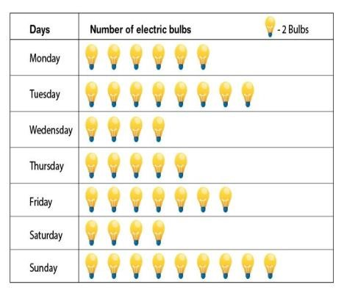
Observe the pictograph and answer the following questions
  - How many bulbs were sold on Friday?
  - On which day were the maximum number of bulbs sold?
  - On which of the days same number of bulbs were sold ?
  - On which day minimum number of bulbs were sold?

हिन्दी (Hindi)
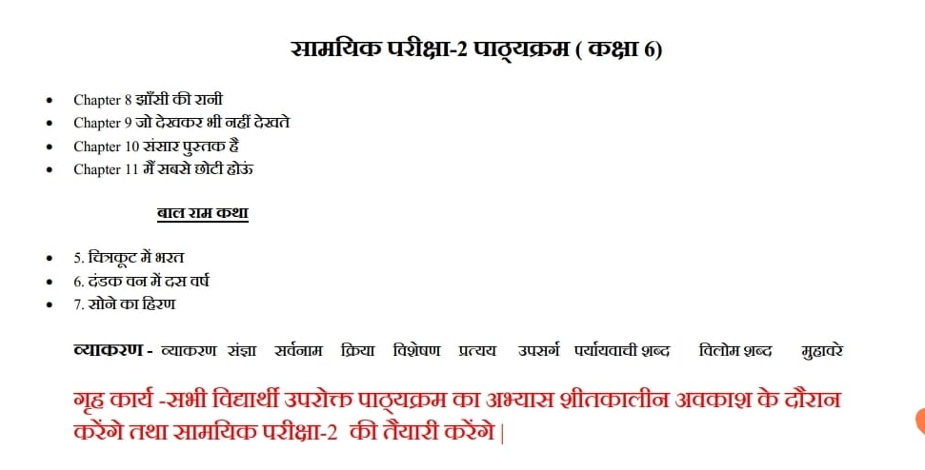

ENGLISH
- READ & LEARN Questions & answers
Honey Suckle
Chapter -WHO I AM,
FAIR PLAY
- POEMS:-
THE WONDERFUL WORDS,
VOCATION
- SUPPLEMENTARY BOOK:-
THE MONKEY AND THE CROCODILE,
THE WONDER CALLED SLEEP
- WRITE A PARAGRAPH-: MY PET
- WRITE AN APPLICATION TO THE PRINCIPAL FOR THREE DAYS LEAVE

SCIENCE
1. What is a habitat?
2. The height of a person is 1.65 m. Express it into cm and mm.
3. Where are poles of a bar magnet located?
4. Where do you get water from?
5. Fill in the blanks :- a) The process of changing water vapour into water is called ……..
b) No rainfall for a year or more may lead to in that region……..
c) The layer of air around the earth is known as ………..
d) The component of air used by green plants to make their food, is……….. .
6. Mark true or false against each of the following :-
a) The evaporation of water takes place only in sunlight.( )
b) Water vapour condenses to form tiny droplets of water in the upper layers of air where it is cooler.( )
c) Artificial magnets were discovered in Greece. .( )
d) Similar poles of a magnet repel each other.( )
7. Draw an electric circuit which consists of an electric cell, bulb and a switch.
8. Differentiate between transparent, translucent and opaque substance. Give examples of each.
9. How would you measure the length of a curved line?
10. When does a flood occur?
11. How a fish is adapted to an aquatic habitat.
12 (a)Draw well labeled diagram of water cycle.
(b) Write any two techniques of rain water harvesting.

SOCIAL SCIENCE
1.Explain the physical divisions of India.
2.Write about the neighbouring countries of India with whom it shares the land boundaries.
3.Write a note on the Environment and it's components and how we can protect it.
संस्कृत
1. अपनी पाठ्यपुस्तक रुचिरा के पाठ- सूक्तिस्तबक:, क्रीडास्पर्धा, कृषिका: कर्मवीरा: नामक पाठों के प्रश्नोंत्तर का दोहरान कार्य करेंगे।
2. निम्नलिखित धातुओं के रूप चारों लकार में लिखेंगे- गम्, पठ्, चल्, खाद् और लिख् धातु आदि।
3. शब्द रूप लिखें - बालक, बालिका, पुष्प, लता, पुस्तक, नदी, मातृ और पितृ शब्द।
4. 1 से 50 तक की गिनती संस्कृत में लिखें।
5. कोई भी 10 श्लोक कंठस्थ करके अपनी कार्य पुस्तिका में लिखें।
6. स्वयं का परिचय संस्कृत में लिखें।

2m is l. We wish you and families a Merry Christmas and Happy New Year!!!
Have a fun filled winter vacation!

