Summer holiday homework
Class -8th
Subject - MATHS

Q.1 a)-5/4 +___=-1. b)3/4+___=0
Q.2 Reciprocal of a is_____
Q.3 What is the product of a)7/8×-4/21 b) -7/8 ×3/21
Q.4 Find two rational numbers between-3 and 3 and for 0 and 1.
Q.5 What is the additive inverse of 3/5?
Q.6 what is multiplicative identity for rational numbers.
Q.7 Represent the following rational numbers on number line. a)3/10 b)7/8 c)21/7
Q.8 multiply the number 29/2 with negative of itself
. Q.9 if you subtract 1/8 from the number and multiply by ¼.you get 1/16 .what is the number.
Q.10 If the product of two rational numbers is-28/81.one number is -2/3 what is other.
Q.11 3/7+(6/11)+(-8/21)+5/22 b)3/8+(-6/5)+5/9+(-8/27)
Q.12 Find the additive inverse of a)-7/19 b)8/17
Q.13 Write the national number equivalent to 9/10 having 90 as numerator.
Q.14 Verify that –(-x)= x for a)-7/19 b) -13/17
Q.15 Find the greater of the two -12/5 and 4/9
Q.16 Write 2/3,-4/9,11/12 in descending order.
Q.17 What should be added to -16/3 to make it 1/ 9
. Q.18 What should be substrate from 5/8 to make it -1.
Q.19 Write the properties of rational number.
Q.20 Solve the following equation a)x+17+3/4 x=9x+1/5 x+7 b)4x+9/4=8x+7/3 c)3y+9/7=5y+7/12. d) .5x = 2×(.45x+9)
SUBJECT-ENGLISH
^{(I)Reading comprehension}
  - ^{How the camel got his hump}
  - ^{Children at work}
  - ^{The selfish giant}
  - The best Christmas present in the world
  - ^{The tsunami}
  - ^{Glimpses of the past}
^{(II)Writing}
  - ^{Notice writing Lost /Found}
  - Notice about speech competition
  - Letter to friend inviting him on your birthday
  - Application to principal for full fee concession
  - ^{Story writing-}
    - ^{The thirsty crow}
    - ^{The lion and the mouse}
    - ^{Greedy dog}
^{(III)Grammar}
- write 50 three forms of the verb and learn by heart
- Learn poem- The Ant and The cricket
^{(IV) Group of twenty(G-20)}
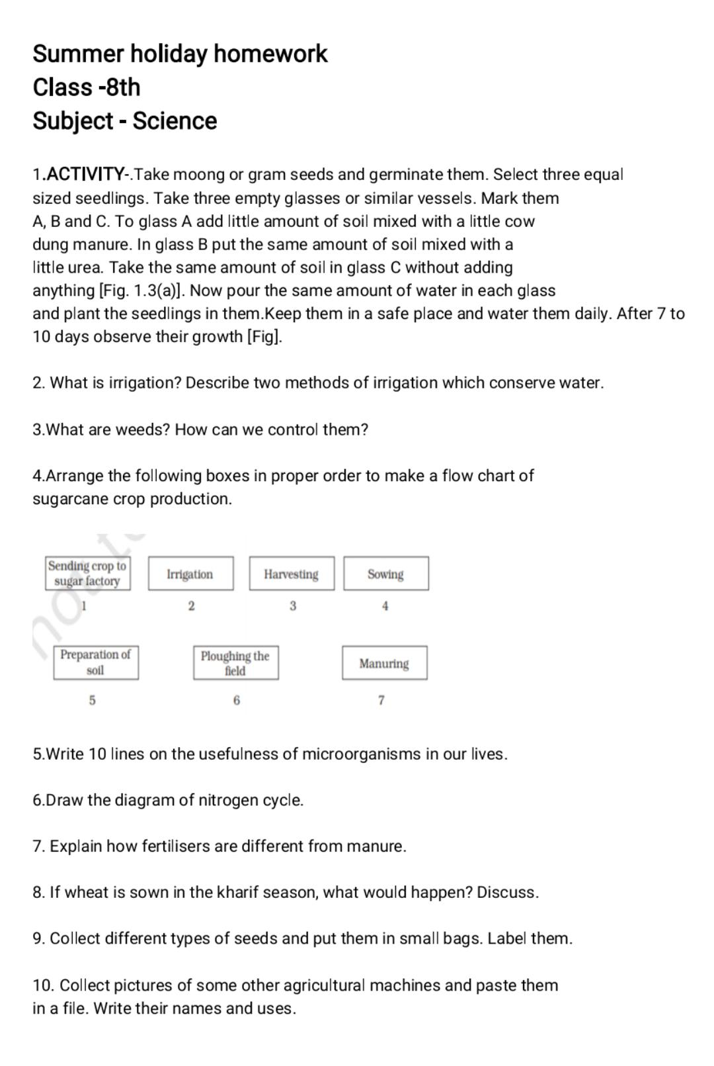
Reading and understanding Questions based on reading comprehension sent in PDF for (VI-VIII) classes
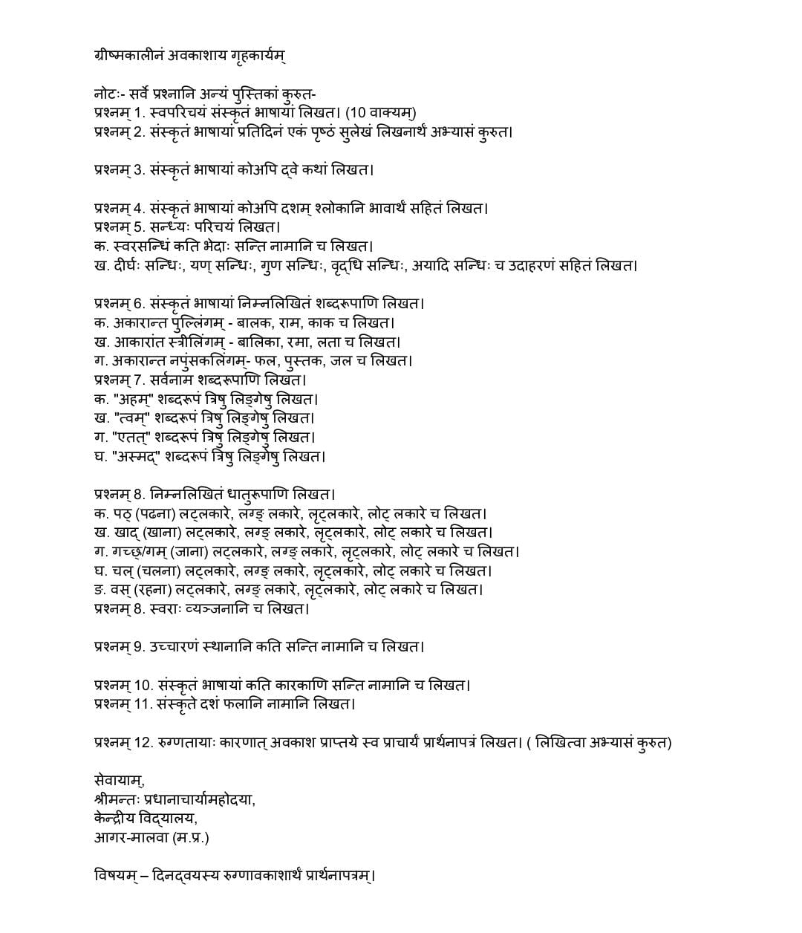
SUBJECT- SANSKRIT

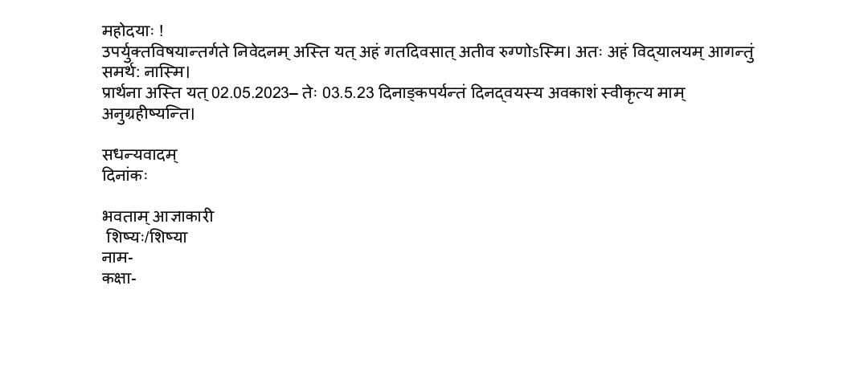

SUBJECT-SOCIAL SCIENCE

- History: Prepare Summary and textbook exercise of Chapter-3
- Geography: Write the summary of Chapter-3
- Civics: Prepare a note on fundamental rights given in Indian Constitution
- Map Work- Show the following on a map of India
    - Chennai
    - Srinagar
    - Arabian Sea
    - Bay of Bengal
    - Indian Ocean

