KENDRIYA VIDYALAYA AGAR MALWA
VACATION HOMEWORK
CLASS III
SUBJECT: EVS
Prepared by : Aishwarya Sharma (PRT)
- ANSWER THE FOLLOWING QUESTIONS:
  - Name two animals that eat grass:
  - Name two animals that eat flesh:
  - Name two animals that live in water:
  - Name two animals that have wings:
  - Name two animals that can hop:
- GIVE EXAMPLES OF:
    - An animal with four legs
    - An animal with long tail
    - An animal with one horn
    - An animal with strong horn
    - A beautiful bird with blue green feathers
    - An animal with shell on its back
- Tick the correct answers:-
A bird: croaks / chirp
A cat: moos / mews
A dog: neighs / barks
A frog: croaks / chirps
A lion: roars / brays
- Arrange the following animals according to the place where they live:-
CROW, LION, TIGER, FISH, PARROT, CROCODILE,OCTOPUS, BEES, SPARROW, ZEBRA, DOG, TORTOISE.
LAND or WATER AIR
- Name the trees or plants which give us:-
- Medicine:
- Perfume:
- fruit:
- Vegetable:

- Name the following:-
- Two big trees:
- Two plants whose flowers you like:
- Two plants whose leaves are eaten :
- Two plants with soft stem:

- DRAW, NAME AND COLOUR TWO SOURCES OF DRINKING WATER.
- WRITE FIVE ACTIVITIES WHICH YOU CAN DO WITHOUT WATER
- Write one good habit you have learned from each of the following elders in your family.
(i) Your grandfather …………………………………
(ii) Your grandmother ………………………………….
(iii) Your uncle ………………………………….
(iv) Your aunt ………………………………….
(v) Your father/mother ………………………………….
10. Name some food items that you like to eat, although your parents say that they are not good for you. Why do your parents say that they are not good for you?
11.
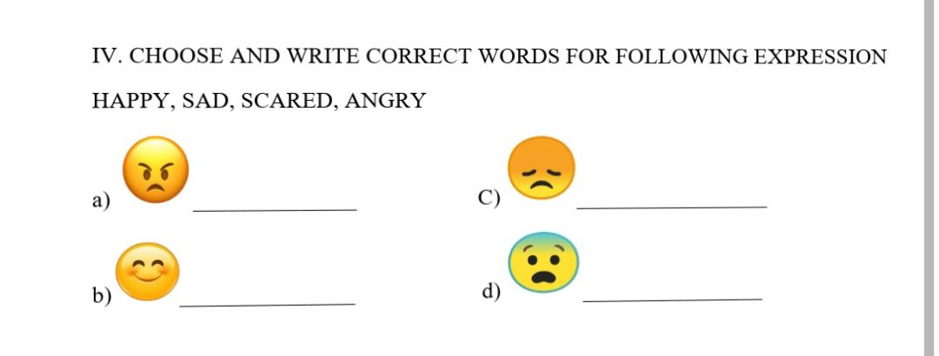

12. Draw your favorite bird. Color it and write five sentences about it.
13. Label the parts of the bird drawn in question 12.
(Beak, eyes, head, wing, claw, tail)

14.
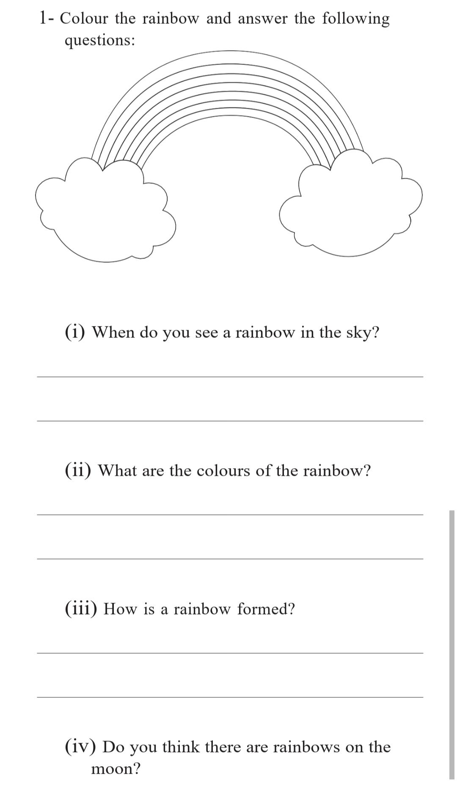
15. Names of some Indian states are given in the table below. Find out one food item unique to each state and the raw vegetable, grain or meat items required to make it. Fill in the information you have found.
Indian state Name of food item Items are required
Kerala …………………………………. ………………………………….
West Bengal …………………………………. ………………………………….
Punjab …………………………………. ………………………………….
Gujarat …………………………………. ………………………………….
16. . STUDY THE FOLLOWING PICTURE AND ANSWER QUESTIONS GIVEN BELOW
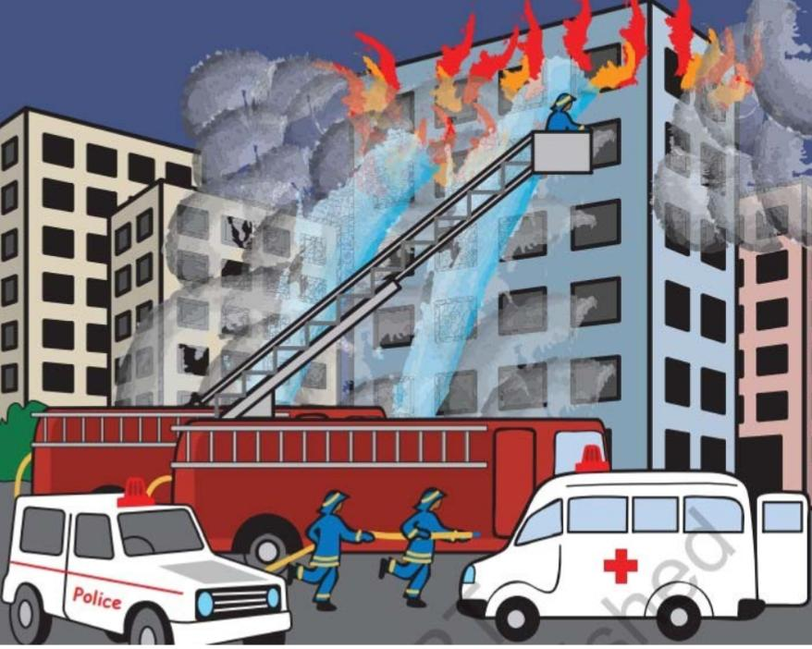

- Name the means of transportation shown in the picture and also write the use of each of them.
- Why is the ladder being put near the burning building?

17. What do we call these buildings places?
  - We wait for the bus here. ………………..
  - We go out for dinner with out parents here………..
  - We go here to worship. ………………..
  - We get petrol filled in our vehicle here…………
  - We buy fresh fruits and vegetables here……………..

18. Name the places you have visited during vacation.
19. Revise chapter 1 and 2 of EVS .
20. Keep water for birds during vacation and write your experience.

Subject – MATHS
- Solve the chapter -1st and 2nd.
- Write the counting from 1 to 300.
- Write the tables from 2 to 15.
- Addition ( One digit)-
  - 5 + 9 (II) 8 + 4 (III) 2 + 9 (IV) 3 + 7 ( V) 8 + 7

- Subtraction ( One digit )
  - 9 – 4 (II) 8 – 3 ( III) 7 – 5 (IV) 6 – 2 ( V) 7 – 3
6. Solve these- ( Two digits)
(I) 4 5 + 3 4 (II) 6 5 + 2 3 (III) 2 3 + 6 1 (IV) 1 6 + 2 1 (v)14 + 33
7. Solve these -
- 6 4 + 5 6 (II) 7 8 + 9 5
(III) 9 6 + 8 6 ( IV) 8 4 + 8 8
8.Subtraction ( two digits ) –
(I) 5 9 – 3 4 (II) 6 7 – 3 3 ( III ) 5 8 – 4 2 ( IV ) 7 7 – 5 1 (V) 8 8 – 7 6
9. Multiplication ( One digit)
(I) 5 X 7 (II) 9 X 6 (III) 8 X 7 ( IV) 5 X 4 ( V) 6 X 6
10. Multiplication ( two digits)
(I) 15 X 17 (II) 29 X 16 (III) 1 8 X 27 ( IV) 25 X 14 ( V) 36 X 2 6
कक्षा 3 हिन्दी

1) 50 तक हिंदी की गिनती शब्दों एवं अंकों में लिखिए।

2) गांधीजी के बारे में एक अनुच्छेद लिखिए।

3) हिंदी भाषा के अंतर्गत उपयोग में लाए जाने वाले विराम चिन्हों के बारे में लिखिए।

4) रोजाना कोई भी 5 शब्द चुन कर उनसे वाक्य निर्माण करो ।

5) अपनी हिंदी की किताब में से कोई एक गद्द्यांश (सुलेख) में कीजिए ।

6) विद्यालय छोड़ने का प्रमाण पत्र मांगने का अनुरोध करते हुए प्रधानाचार्य को प्रार्थना पत्र लिखिए।

7) रोजाना हिन्दी भाषा के 2 पेज पढ़ने का अभ्यास करें।

8) नीचे लिखे शब्दों की जगह और कौन-सा शब्द इस्तेमाल हो सकता है? खाली जगह में लिखो।
1.बुद्धिमान- ..................2.मूर्ख.................3.अभिमान.................4.विश्वास.................5.संसार..................6कोशिश..................
9) संज्ञा किसे कहते हैं – परिभाषा, भेद एवं उदाहरण I

10) भूजल भंडार को कैसे सुरक्षित रखा जा सकता है, अपने सुझाव दीजिए एवं चित्र भी बनाइए ।

English
1.Do 1 page writing daily in cursive and reading also.
2.Learn word meaning, questions and answers of chapter 1,2,3.
3.Make a scrapbook of flowers according to English book’s page no.page no. 7,8.
4. Draw a garden picture and colour it.
5 . Learn 6 lines of the poem chapter 1.
6. Name the five things given the page no. 8 accordingly.
7. Learn and write definition of Noun , pronoun and their types of.
8. Write and learn 20 opposite words.
9. Write and learn 20 verbs and 20 singular , plural words.
10. Make birds according to English page no. 20.

HAPPY HOLIDAYS!!!!

