ACADEMIC SESSION 2023-2024

CLASS-1st

Fun Filled Activities
Dear children,

'Merry Christmas & Happy New Year'

We wish you and families a Merry Christmas and Happy New Year!!!

Have a fun filled winter vacation!
________________________________________________________________________________________________________________
केंद्रीय विद्यालय आगर – मालवा
शरद कालीन गृहकार्य(2023- 24)
विषय – हिन्दी गृहकार्य

1. 1 पेज सूलेख लिखना एवं पढ़ना प्रतिदिन।
2. बारहखड़ी बोल - बोल कर लिखना ।
3. हिन्दी में 5 फलों , फूलों, रंगों, जानवरों, पक्षियों एवं यातायात वाहनों के नाम लिखवा एवं उनकी फोटो चिपकाना।
4.पाठपुस्तिका के पाठ 13 की कविता याद करना ।
5. सभी मात्राओं से 5 पांच - पांच शब्द बनाना।

KENDRIYA VIDYALAYA AGAR MALWA , M.P.
Session -2023-24
WINTER VACATION HOME WORK
CLASS -I
SUBJECT -MATHS

1. Reverse counting 100 to 1. (2 times)
2. Table writing 2 to 6. (2 times)
3. Name the tallest and shortest member of your family.
4. Name the coins currently in use in India.
5. Name the notes currently in use in India.

KENDRIYA VIDYALAYA AGAR MALWA , M.P.
Session -2023-24
WINTER VACATION HOME WORK
CLASS -I
SUBJECT –ENGLISH

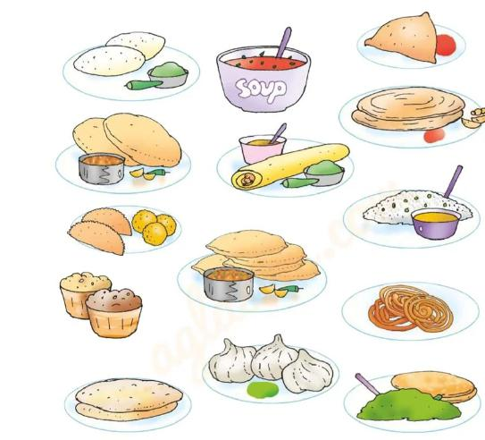
Qus.1 See the pictures and answer the following questions.
A.Writethe food items you see in the picture.

B.Which is your favourite sweet?

C.Who cooks food at home?

Qus.2 Say the names of the special dishes eat at you home. Draw and colour them.

Qus.3Match the food items to its shape.
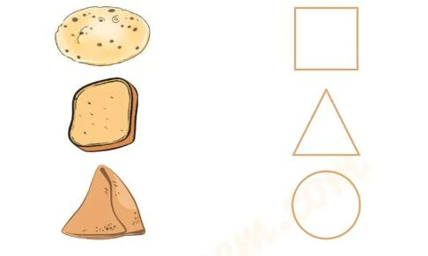

Qus.4. Match the following image to the sentences.

Qus.5. Do 1 page English handwriting .

KENDRIYA VIDYALAYA AGAR MALWA , M.P.
Session -2023-24
WINTER VACATION HOMEWORK
CLASS -I SUBJECT – EVS
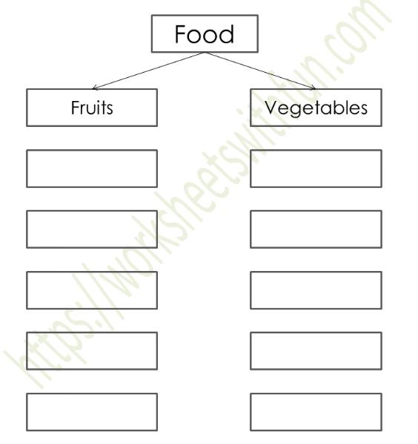
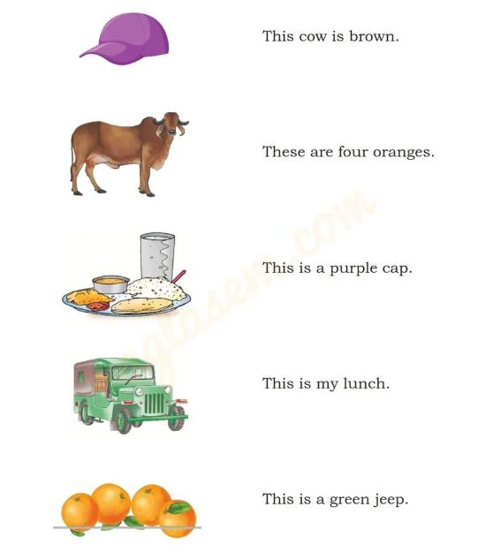

Qus.1. Complete the tables.

Qus.2 Identify the following food and write their names.

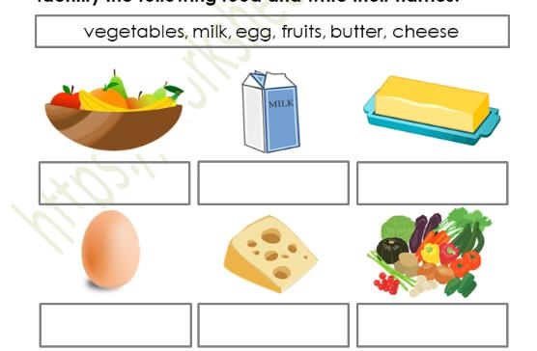
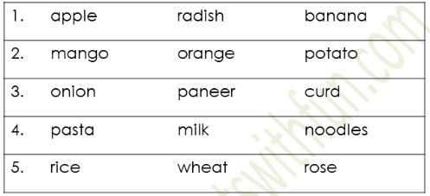
Qus.3 Circle the odd one out.

Qus.4 Match the food to its source.

Qus.5. Name any three milk products.
1.………………..
2.…………........
3.…………………

