KENDRIYA VIDYALAYA AGAR MALWA
WINTER BREAK HOLIDAY HOMEWORK

Date: 25 Dec. 2023 to 3 Jan. 2024
CLASS -8TH

MATHEMATICSf
If z=10, find the value of z³-3(z-10).

- If p=-10, find the value p²-2p-100

What should be the value of a if the value of 2x²+x-a equals to 5, when x=0?
Simplify the expression and find its value when a = 5 and b =-3. 2(a²}+ab)+3-ab

• Solve the following questions

- What should be added to x² + xy + y² to obtain 2x² +3xy

- What should be subtracted from 2a+8b+10 to get-3a+7b+16?

What should be taken away from 3x²-4y²+5xy+20 to obtain -x²-y²+6xy+20?

- From the sum of 3x-y+11 and -y -11, subtract 3x-y-11 .

- From the sum of 4+ 3x and 5-4x + 2x², subtract the sum of 3x²-5x and -x²+2x+5.

Express the number appearing in the following statements in standard form.

- 1 micron is equal to 1
1000000m.

- Charge of an electron is 0.000,000,000,000,000,000,16 coulomb.

- Size of a bacteria is 0.0000005 m

- Size of a plant cell is 0.00001275 m

v) Thickness of a thick paper is 0.07 mm

In a stack there are 5 books each of thickness 20mm and 5 paper sheets each of thickness 0.016 mm. What is the total thickness of the stack.

10. There is a pentagonal shaped park as shown in the figure. For finding its area Jyoti and Kavita divided it in two different ways.

Find the area of this park using both ways. Can you suggest some other way Of finding its area?
11. Diagram of the adjacent picture frame has outer dimensions = 24 cm x 28 cm and inner dimensions 16 cm x 20 cm. Find the area of each section of The frame, if the width of each section is same.
Find the side of a cube whose surface area is 600 cm³.
Rukhsar painted the outside of the cabinet of Measure 1 m x 2m x 1.5 m. How much Surface area did she cover if she painted all except the bottom of the cabinet.

Water is pouring into a cubiodal reservoir at the rate of 60 litres per minute. If the volume of reservoir is 108 m³, find the number of hours it

Will take to fill the reservoir.
(1)How many times will its volume increase?

हिन्दी (Hindi)
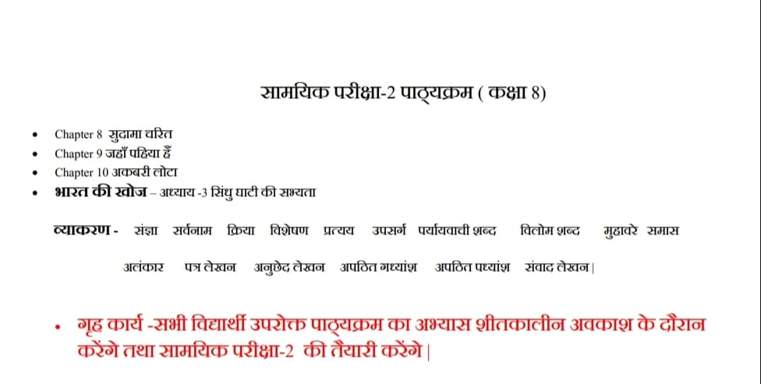

ENGLISH
Honey Dew:-
Read and Learn Questions and answers
1) This is Jody's Fawn
2) A Short Monsoon Diary
Supplementary Book:
1)The Fight
2) Jalebis
Poem:-
1) The School Boy
2) The Duck and the Kangaroo
Write:- An application to the Principal of your school for three days leave on the occasion of your Brother's Marriage.
Prepare MDP for Term- II assigned by your Class-teacher.
SCIENCE
FILL UP THE BLANKS
1.To move a loaded trolley we have to -----------------it.
2. The north pole of a magnet -------------- the north pole of another magnet.
3. Sprinkling of powder on the carromboard ----------------- friction.
4. Sliding friction------------------- than the static friction.
5. Loudness of sound is determined by the -----------------of vibration.
6. Unwanted sound is called---------.
7. Most liquids that conduct electricity are solution of ---------------
2. TICK THE TRUE AND FALSE
1. Sound can travel in vacuum ( )
2. Noise pollution may cause partial hearing impairment ( )
3. The friction is sometimes undesirable ( )
4. Earthquakes can be predicted in advance ( )
5. Gravitational force is non-contact force ( )
4 Difference between REGULAR AND diffused REFLECTION
3 . A ball rolling on the ground slows down and finally stops. This is because of –
(a) Force (b) less force applied (c) friction (d) none of above
2. Write the two example of non-contact force ?
3. Name the scale on which the destructive energy of earthquarkes is measured?
4. Give two example of each to show that friction is both a friend ,a foe. ?
5. Prepare a list of objects around you that are electroplated.
6. Does pure water conduct electricity? If not, what can we do to make it conducting?
7. Define following terms (a) Amplitude (b) Frequency (c) Electroplating
8. Suggest three measures to protect ourselves from lightning.
9. Explain in what way noise pollution is harmful to humans.
10. Is it safe for electrician to carry out electrical repairs outdoors during heavy downpours? Explains.

SOCIAL SCIENCE
1 .Define -1 sati 2 Migration 3 population change
2.Mahatama Gandhi's and Tagore's views on Indian education system
3. Marginalisation and ways to confront it.
4 prepare a map showing all the states of India along with their capitals
संस्कृत
1. स्वयं का परिचय संस्कृत भाषा में लिखेंगे।
2. संस्कृत में 1 से लेकर 100 तक गिनती लिखेंगे।
3. अपनी पाठ्य पुस्तक रुचिरा के पाठ- सप्तभगिन्य:, नीतिनवनीतम्, सावित्री बाई फुले नामक पाठों के प्रश्नोत्तर का अभ्यास करेंगे।
4. कारक, स्वर व्यंजन, संधि(स्वर संधि), विभक्ति रूप (इदम्, एतत्, बालक, बालिका, पुष्प, नदी आदि), धातु रूप (पठ्, चल्, खाद्, गम्, वद्, दृश् धातु आदि) व आदि को लिखकर के अभ्यास करेंगे।
5. कोई भी 10 श्लोक कंठस्थ करके अपनी कार्य पुस्तिका में लिखें।

2m is l. We wish you and families a Merry Christmas and Happy New Year!!!
Have a fun filled winter vacation!

